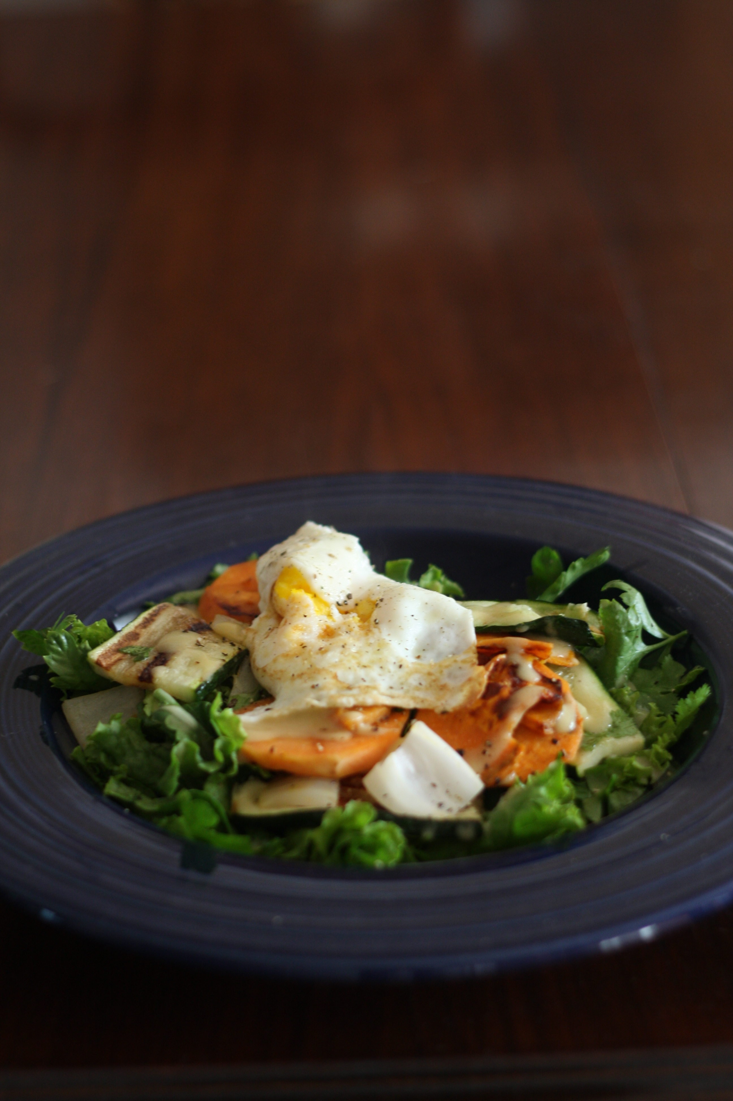
Warm Sweet Potato and Zucchini Salad
**I admit that this recipe doesn’t really fit into the theme of this blog since sweet potatoes aren’t in season. I’m trying to do a better job of cooking seasonally and locally, but I do have a soft spot for these little guys so I hope you will give me a pass just this once.

2-3 sweet potatoes, peeled and sliced ¼” thick
1-2 zucchini (green or yellow), sliced lengthwise ¼” thick
Salad greens (Source: FFM)
Cilantro and Parsley (Source: Fire escape garden)
1-2 fried eggs (Source: FFM)
S&P

Dressing:
1-2 TBL Dijon mustard
1 TBL white balsamic vinegar
1-2 TBL olive oil

Brush olive oil on sweet potatoes and zucchini slices. Grill on your grill pan until tender. Note: The zucchini slices will cook much faster than the sweet potatoes! Make up your dressing. Cook fried egg, leaving the yolk a little runny. S&P your greens and divide sweet potato and zucchini plus greens into two or three salad portions. Drizzle dressing on top and “garnish” with egg.

