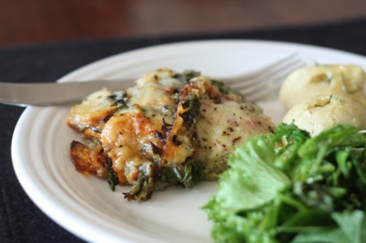
Swiss Chard and Sweet Potatoe Gratin
***I found this recipe on the Smitten Kitchen Blog and sort of halved it since I didn't have as much chard as she suggests and didn't want too heavy of a sauce considering the weather. Also, I put this together and baked it on Saturday and it heated up and served very well today- a great option if you don't feel like turning on the oven after a day at work or because it's too damn hot!
1 bunch swiss chard, more if you've got it!, washed and chopped coarsely (Source: FFM)
2-3 sweet potatoes, peeled and thinly sliced (1/8" setting on mandoline)
1 large onion, diced
2 cloves garlic, smashed and chopped finely
1 C whole milk or heavy cream (Source: Snowville Creamery, FFM)
1 TBL flour
1-2 TBL butter (Source: FFM)
cheese
s&p
fresh flat leaf parsely (Source: Fire escape garden)
Prep your onion, garlic, greens and potatoes. Saute onions and greens in a little butter. The original recipe warns against liquid and draining it off, but I didn't have any?? Set aside when wilted, after about 5 or so minutes. TIP: If you are using the stems, put them in first and let them soften up a bit before adding the leaves. I didn't use mine as I tossed them into my crockpot batch of veggie stock!
To make the sauce, melt the remaining butter and whisk in the flour. Cook for about 1-2 minutes and add garlic. Warm milk for about 30 seconds in the microwave or in a saucepan if you're anti-microwave. Slowly whisk in milk to avoid clumps. S&P the sauce- congratulations, you've made a bechamel sauce one of the mother sauces! Whisk over medium heat until thickened.
Grease a 9x9 glass pan and layer sweet potatoe slices, a little cheese, S&P, and then half of the chard mixture topped with half of the sauce. Repeat with remaining ingredients and put a little cheese on top too. Bake for about 45 minutes or so at 400F. I baked mine a little less knowing that I would be heating it up on Monday and because I didn't have as much sauce as the original recipe.

