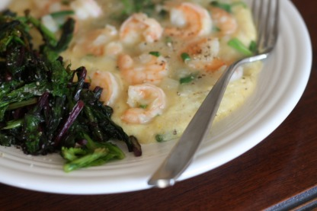
Shrimp 'n grits
***I originally found the recipe for the shrimp in this dish on Food Network's website. I should have trusted my gut when I had doubts about the preparation because it definitely not my favorite. So this recipe represents what I should have done and will do in the future when I make this again. Because even though the shrimp was a little bleh, the grits and greens were amazing!
1 C stone ground cornmeal (Source: Stutzman Farms, FFM)
1 C water
1.5 C chicken or veggie stock (Source: homemade from the bones from our FFM chicken)
1/4 C whole milk or cream (Source: Snowville Creamery, FFM)
4 oz chevre (Source: courtesy of Lucky Penny Farm)
1 TBL butter
fresh parsley (Source: fire escape garden)
fresh chives (Source: fire escape garden)
Shrimp- try to find some big tiger shrimp, mine were a little sad
1 medium onion, diced
2 cloves garlic, finely chopped
1 TBL butter
1 TBL olive oil
Mustard greens (Source: FFM)
Beet greens (Source: FFM)
2 TBL olive oil
Chevre Grits-
Bring stock and water to a boil and lower heat to medium low. Add cornmeal in slowly while whisking to avoid lumps. Stir occasionally and let grits cook for about 5-10 minutes or so. Whisk in the butter, milk, and chevre and remove from heat.
Shrimp-
Heat oil and butter in a skillet and cook onions and garlic until soft. Saute shrimp until pink. Be careful not to overcook the shrimp as they will become tough.
Greens-
Saute your greens on high heat in a skillet with olive oil. S&P to taste
Serve shrimp and greens over grits.

