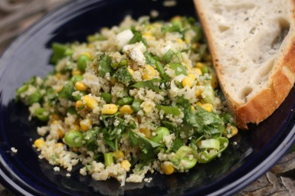

Quinoa Summer Salad
**I adapted this recipe from one in Bon Appetit magainze that used farro, which at the time I didn't have so I subbed quinoa and it was a masterpiece! The measurements are pretty much all relative and this recipe is so adaptable to what you have on hand and your tastes. There are very few of what I call "non-negotiable" ingredients in this dish that make it a hit time and time again: the dressing, the feta or goat cheese, green onions, and fresh herbs. The rest is up to you.
1 C quinoa, organic if you can find it
2 C water
blanched green beans (I used edamame because its what I had on hand!)
fresh corn (frozen works too in a pinch, just run it under water and drain)
green onions
fresh herbs- I like to use parsley or cilantro, basil is a little too savory for this recipe so I wouldnt use it
feta or chevre (Source: Blue Jacket Dairy)
spicy grainy mustard
lemon juice
olive oil
garlic or shallot
kosher salt
**if I have grape or cherry tomatoes I halve them and toss 'em in for a little extra color
Cook quinoa either on the stovetop or in the microwave. I like to use the fewest dishes possible so I microwave mine in a big bowl- 1:2 ratio of quinoa to water. Cook uncovered in microwave for 5 min at 100%. Then cover and cook for 10-15 min. on 30%, stopping to stir halfway through. Fluff with a fork and set aside while you chop.
Chop your veggies and herbs. Combine garlic or shallot and kosher salt and press with the back of a spoon into a small bowl to mash the garlic up a bit. Mix lemon juice (usually use about 2 TBL) and grainy mustard (about 1-2 TBL) and olive oil (1-2 TBL) with garlic and salt mixture. Dump your veggies, herbs, and dressing in with the quinoa and toss to coat evenly. S&P and add feta or chevre and toss gently.

