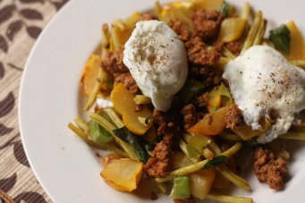
Patty Pan Squash Hash
2 patty pan squash, chopped into about 1" pieces (Source: FFM)
2 leeks, sliced (Source: FFM)
1 lb romano yellow beans (Source: FFM)
1 lb Berkshire Pork Chorizo (Source: FFM)
2 poached eggs (Source: FFM, I had some left over from a few weeks ago)
fresh basil
S&P
Prep your veggies and heat 1-2 TBL olive oil in a skillet over medium heat. Toss in your squash first and saute about 5 min. Add beans and leeks and increase heat to medium high in order to get some carmelization going. While your veggies are working, cook up your chorizo (or whatever you are using) in a non stick pan. Boil some salted water and poach your eggs 1.5-2 min. Toss veggies with chorizo (and resulting fat, it's seasoned from the sausage so don't throw it away!) and serve poached eggs on top. S&P to taste, and you could always garnish with some cheese too.

