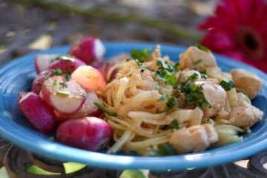

Paprika Chicken with Buttered (Or Olive Oiled) Warm Radishes
adapted from Rachel Ray
(*** Disclaimer: I am not a huge fan of Rachel Ray because its seems like everything she makes is the same and I am so tired of her tired little "yummo" phrases. However, this recipe is great! Trust me, and I hope you enjoy my take on it)
8 oz egg noodles or spaghetti, fresh or dried
2 lbs chicken, choose your favorite- white or dark meat, cut into bite size pieces
1 medium onion, thinly sliced (I usually use either yellow or vidalia onions)
2-3 garlic cloves, chopped
2 tsp sweet paprika, smoked if you have it
1/2 C water or chicken stock (please dont use canned or boxed stock or boullion cubes, if you dont have homemade stock, just use water. I promise it will come out fine!)
2-3 TBL butter
1 lb radishes, trimmed and halved
1/2 C sour cream, or plain non fat yogurt, or heavy cream (Ive used all three and they all work, though the sour cream/yogurt result in the creamiest dishes)
Chives
Parsley
S&P
Olive oil
Cook up your pasta to al dente in salted water. Drain and return to the pan with a little butter.
Brown your chicken in a skillet in olive oil for about 3-4 min. Add the sliced onions and garlic, paprika, and S&P. Cook for a few minutes and then add your stock or water to deglaze the pan and let simmer for about 2 min.
While this is working, heat up a little butter in a skillet and toss your radishes in cut side down for 2-3 min. Flip/stir and cook for an additional 1-2 minutes, until tender and remove from heat. Toss with chives and S&P.
When the chicken pan is deglazed, remove from heat and stir in the sour cream.
Serve the chicken on top of the pasta and sprinkle fresh parsley on top. Serve radishes on the side.
**Makes great leftovers (this recipe serves about 4 people)

