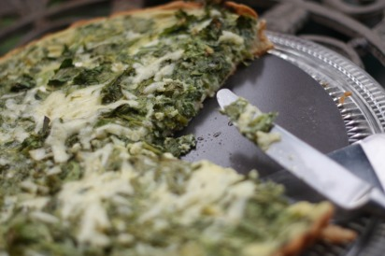
Mustard Green Tart
**I found a recipe for this savory tart with Turnip greens and figured mustard greens would be a great substitution. Thanks to 101cookbooks.com for this recipe. I have made some changes based on what I had to work with plus I never seem to be able to leave a recipe well enough alone! You can substitute a homemade or store bought (if you have worked late, are lazy, or just plain bad at making pie/tart crusts like me) pie crust for the cornmeal tart shell if you are pressed for time. This recipe is extremely easy so don't let the laundry list of ingredients and instructions fool you.
Cornmeal Tart Shell
2 1/4 C AP flour
1 C spelt flour
scant 1 cup medium coarse corn meal
3/4 tsp salt
1 1/4 C unsalted butter, cut into pieces
1 large egg yolk
1/4 C cold water
Mustard Green Filling
1/4 lb mustard greens destemmed (*I used my entire bunch of mustard greens because I was using an 11" tart shell and because I didn't want to waste any greens, probably about 1 lb)
1 head of green garlic, finely chopped (no easy feat, use your food processor for sure) (Source: FFM)
2-3 green onions, diced (Source: FFM)
2 large eggs + 1 yolk (I ended up using about 4 eggs and 1 egg yolk because I had so many greens and a large tart pan plus I didnt have any heavy cream and I wanted to make sure it wouldn't end up too watery) (Source: FFM)
3/4-1 C vegetable broth (Source: homemade chicken broth using the bones from our chicken from last week)
1/4-1/2 C heavy cream (or, you can use 2% milk plus a few TBL of butter like I did- the butter from FFM is so good I could eat it on a spoon)
S&P
2-3 TSP dijon mustard
bunch parsley (Source: Fire escape garden)
Gruyere or Swiss Harvarti (Source: FFM, Mayfield Road Creamery)
Tart Dough
Combine flours, cornmeal and salt in food processor. Pulse in butter until pebble like mixture forms. Add egg yolk and 1/4 C water. Pulse and add more water if needed to make a ball. Divide dough into two pieces and chill for about an hour before rolling/pressing one disc into your tart pan. Freeze the other half for another day. Chill tart for about 30 minutes and partially bake with pie weights for about 25 min. Let cool while you prepare the filling.
***I did not have the time or trust that I could actually make a tart crust. So I bought a pastry crust and just pressed it into my 11" tart pan. I got the pan at one of my Bridal Showers 3 years ago and I haven't gotten a chance to use it until now and by was I excited. I could've used a regular pie pan as well if I wanted. I did not prebake my crust either. Just refrigerated it after I pressed it into the pan while I made my filling.
Chop greens and green garlic finely. Whisk eggs and cream and dijon mustard with the broth in a large bowl. S&P. Add greens, green garlic and parsley. S&P. Sprinkle some of the grated cheese on the bottom of the tart crust and pour the filling into the crust. Bake for about 30 minutes until the center is set. For the last 5 minutes of baking I sprinkled the rest of the cheese on top. Then I let it set on the counter about 5 or so minutes before I took it out of the pan and served it so that it could set up a little more.

