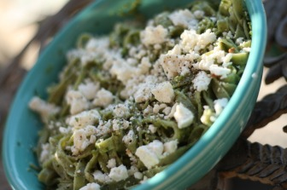
Monster Green Pasta
**I really do need to work on getting exact measurements, but it's just not how I cook. So I apologize in advance for those of you that are frustrated by my recipes. I used pistachios in lieu of pine nuts because that's what I had on hand and I often use them in another pesto recipe. But feel free to make substitutions based on what you have and like!
1 lb spinach fettucini (Source: Ohio City Pasta, see link above)
bunch of scapes (I had 2, Source: FFM)
basil (Source: Fire escape garden)
pistachios (I used about 1/8-1/4C)
lemon juice (about 1-2 TBL)
olive oil (about 1/4 C)
feta (Source: Blue Jacket Dairy)
To make the pesto, finely chop scapes and put in food processor with pistachios (or other nuts), the lemon juice and a little olive oil. Pulse 1 min and add the rest of the olive oil and pulse until smooth. Add S&P.
Boil salted water for your pasta. Salting your water is extremely important and Gorden Ramsey is always yelling at the contestants on Hell's Kitchen about it. Don't be a donkey, salt your water! Cook pasta to al dente- fresh pasta takes about 4-8 min. Drain and mix with pesto and feta immediately. Serve warm.

