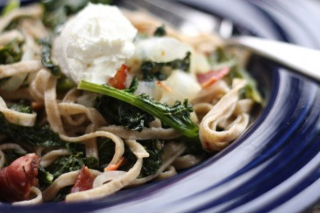
Kale Whole Wheat Fettucini
**Swiss chard is another one of my favorite greens and goes well with a fatty meat like bacon. If you're meat free, pine nuts and cranberries are also delicious! This recipe made enough for the two of us to have large helpings and leftovers for lunch.
1 lb fresh whole wheat fettuccine (Source: Ohio City Pasta, FFM)
1-2 lb Kale- any kind of you like (Source: FFM)
1 large onion sliced thinly on a mandolin- 1/4" thick
3-4 cloves garlic diced
red pepper flakes
olive oil
8 oz bacon (Source: New Creation Farm, FFM)
2-3 oz chevre (Source: Lucky Penny Farm)
Clean and destem your chard. You will probably feel like you have way too much chard. You don't, trust me. It will cook down to a manageable portion. Slice up your onions and dice your garlic. Bring salted water to a boil. Cook up your bacon and chop coarsely.
Heat olive oil in skillet on medium-high heat and cook your onions 'til golden. Carefully add the chard in batches, allowing each batch to cook down a little bit before adding the next to make room in the pan. When swiss chard is all in the pan, let it wilt down about 5+ minutes. Add garlic and red pepper flakes S&P and cook for another 5 minutes or so until the chard is tender but still green. Cook pasta to al dente- fresh pasta takes about 4-6 minutes. Drain pasta and add to skillet with your greens. Toss in the bacon. Serve with a dollop of chevre or crumbled feta on top.
**Note about the chevre: Lucky Penny gave me a 4 oz container of the chevre about 2 or so weeks ago. I used most of it in the cheesecakes last week and it was still good this week, despite being past it's "use by date" which was a pleasant surprise!

