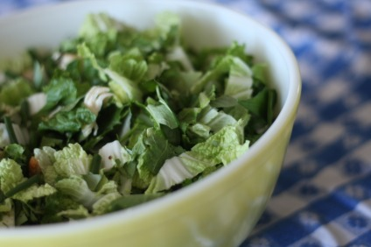
Giant Bowl of Goodness
**I got tired of having the word salad in my recipes and this description seemed pretty appropriate. If you cant find some of these specialty ingredients, substitute cilantro and parsley.
Cabbage, I had koboku and as they say, necessity is the mother of invention (Source: FFM)
Mint (Source: Minh Anh Vietnamese Market)
Rau Rum (Source: Minh Anh Market)
Cilantro (Source: Fire escape garden)
Green Onions (Source: Fire escape garden)
Optional: Shredded chicken breast, Mango slices
Dressing:
Wasabi Paste (Source: Tink Holl Market)
Sesame oil- only use a few drops as this can be a pretty dominant flavor (Source: Tink Holl Market)
Rice wine vinegar
Lite soy sauce
Whisk together dressing ingredients. Chop greens and herbs. Toss with shredded chicken, sliced mango and greens. S&P to taste. Serve with crusty bread and butter.

