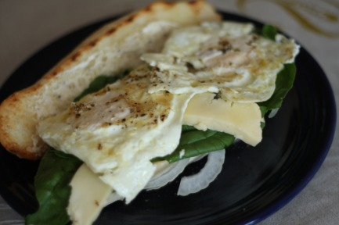

Egg "Salad" Sandwiches
*This isn't so much a cut and dry sort of recipe. Add your favorite toppings and there are no exact measurements. Perhaps that's why I'm a better cook than I am a baker- in my everyday job, measurements have to be precise and exact, but at home I can just be creative and cook to what tastes "right"! This quantities I have given are for one sandwich.
1 Sausage Bun (Source: our FFM bundle!)
2 free range eggs (Source: Holistic Farms, see link above)
2-3 slices of grass fed Blue Gouda Cheese (Source: Mayfield Creamery)
1-2 spinach leaves (Source: our FFM bundle!)
Garlic Aioli- just finely chop some garlic and mix it with either store bought mayo or homemade!
Thinly sliced onions (I like to use yellow or vidalia onions but use whatever you like)
Butter
Lightly butter sausage bun and grill until warm and toasted (I used my grill pan!). Warm some butter in a non stick skillet and cook eggs to your preference (I basically fried mine). **IMPORTANT*** In my opinion, when you cook eggs you should always S&P them while they are cooking. Shmear the garlic aioli on the bun and layer onions, cheese, spinach and eggs. Enjoy!

