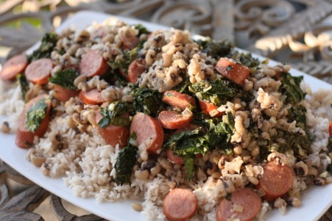
Dirty Rice and Greens
***Again, if you think you have too many greens, add some more. They cook down considerably and they will be so good you will be wishing for more. This is not really a traditional dirty rice dish but it incorporates a lot of Southern flavors that I personally like
1-2 lbs collard greens, stems and ribs removed (Source: FFM)
1 large onion, diced
4 cloves garlic, chopped finely
1/2 lb black eyed peas, dried
1Andouille or smoked sausage, sliced
2 C rice
4 C water or stock
1-2 TBL spicy grainy mustard
S&P
Either soak your black eyed peas overnight or place into 2-3 C of salted, boiling water for 2 minutes. Remove from heat and cover for about an hour. When you are ready to prepare your dinner, heat the peas up again and then drain the water off and reserve. Use the black eyed pea water to boil your rice according to the package instructions- 1:2 rice to water ratio. Add 1-2 cloves garlic, 1/4 of the onion and a little olive oil and S&P to the peas and heat up until the garlic is cooked. Meanwhile saute the rest of the garlic and onion in olive oil. Add the sliced sausage to this pan and saute for about 1-2 min. Add your greens in batches. S&P. When the greens are wilted add 1-2 TBL grainy mustard to the pan and stir. Serve the greens, sausage and peas over rice. S&P to taste. If you're feeling spicy, add a little Siracha sauce.

