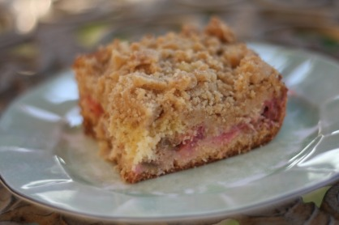

Crumb Coffee Cake with Rhubarb
***I found this recipe on another blog and it was an adaptation of a New York Times Recipe. If you don't have rhubarb try another fruit- I bet it would be great!
For the filling:
1/2 lb rhubarb, trimmed and diced 1/2" thick (Source: FFM)
1/4 C sugar
2 tsp cornstarch
1/2 tsp ground ginger
1/8 tsp cardamom
For the topping:
1/3 C dark brown sugar
1/3 C sugar
1 tsp ground cinnamon
1/2 tsp ground ginger
1/4 tsp nutmeg
1/4 tsp salt
1/2 C (1 stick or 4 oz) butter, melted
1 3/4 C flour
For the cake:
1/3 C sour cream
1 large egg + 1 egg yolk (Source: Holistic Farms, FFM)
2 tsp vanilla
1 C flour
1/2 C sugar
1/2 tsp baking soda
1/2 tsp baking powder
1/4 tsp salt
6 TBL softened butter, cut into pieces (Source: FFM)
325 degree oven
Grease 8" square pan. Mix sliced rhubarb and toss with sugar, cornstarch, and spices. Set aside.
In a large bowl, whisk sugars, spices and salt into melted butter until smooth. Then add flour with a spatula. Press it together in the bottom of the bowl and set aside.
In a small bowl mix sour cream, egg and yolk, and vanilla. Mix flour, sugar, baking soda, baking powder and salt with the paddle attachment on your mixer. Add butter and a spoonful of sour cream mixture and mix on medium speed until flour is moistened. Increase speed and beat for 30 seconds. Add remaining sour cream mixture in two batches, beating for 20 seconds after each addition, scraping down the sides of the bowl with a spatula. Scoop out 1/2 C batter and reserve. Scrape remaining batter into prepared pan. Spoon rhubarb over batter. Dollop remaining batter over the rhubarb. Break the topping mixture into big crumbs and cover the ake. Bake 45-55 min. Cool before serving.

