Cornmeal Veggie Pie
Originally appeared on Elly Says Opa!
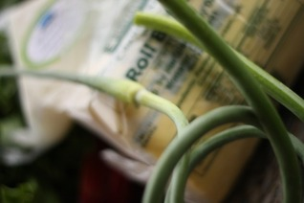
Crust:
3/4 C cornmeal (Source: FFM)
3 TBL flour
1 TBL melted butter
1 1/2 TBL olive oil
salt and freshly ground pepper
1/4-1/3 C water, milk or broth
Filling:
2 tsp olive oil
1/2 small onion, diced
1 red pepper, coarsely chopped
1 small tomato, seeded and chopped
2 cloves garlic, minced, divided (I used my garlic scapes- Source: FFM)
1/2 tsp herbs de provence
1 TBL balsamic vinegar
1 tsp butter
8 oz sliced mushrooms
1 zucchini, thinly sliced
3/4 C asiago cheese, divided
1/2 lb asparagus spears
Preheat oven to 400 and spray a pie or tart pan with a little oil.
To make the crust, whisk together cornmeal, flour, butter, oil, and salt and pepper. Add a little liquid until you get a dough that sticks together when pinched (like a graham cracker crust). Press the mixture into the bottom of the prepared pan and set aside.
Heat 2 tsp olive oil in a pan over medium heat. Stir in the onion and saute for about 3-4 minutes before adding the red pepper, tomato, 1 clove garlic (or scapes), and herbs de provence. Continue cooking about 5 more minutes until vegetables are tender. Add balsamic vinegar, scrape up bits stuck to pan and allow to evaporate., Move the mixture to a food processor pulse until smooth.
Wipe out the pan and add the butter. Cook mushrooms and the remaining clove of garlic (or scapes) until the mushrooms have given up all their juices and they are reabsorbed.
Build the pie by placing zucchini in concentric circles, slightly overlapping over the crust. Spoon the mushroom mixture on top of the zucchini, followed by all but 2 TBL of the cheese. Spread the roasted red pepper sauce across the pan. Layer asparagus spears in a radial pattern on top of the sauce. Sprinkle with remaining cheese and bake for 30-35 minutes.

