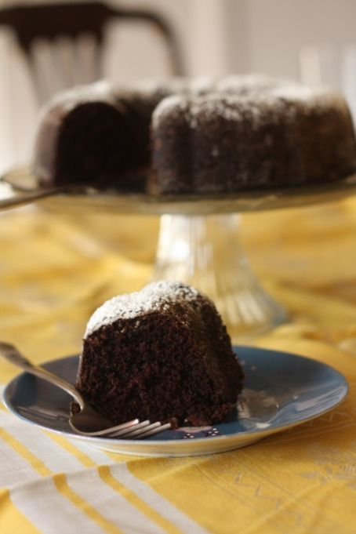
Chocolate Beet Cake
***There are many, many beet cake recipes out there. I chose to combine a few recipes based on my idea that more chocolate would make the beets taste better. The worst part about this recipe is that you have to boil the heck out of the beets before you can skin and puree them. Other than that, it's a breeze!
1 C salted butter
1 1/2 C packed dark brown sugar
3 eggs
4 oz dark chocolate
3 medium beets, pureed (Most recipes recommended more, but that's all I had) (Source: FFM)
2 tsp vanilla
2 C flour
2 1/2 tsp baking soda
1/2 tsp salt
1/2 tsp cinnamon
pinch nutmeg
1/4 C semi-sweet chocolate chips
Cook your beets by boiling them for at least 30 minutes. Let cool and slip skins off and puree the beets. I used my mini food processor but thought about using my blender so I'm sure either would work.
Cream 3/4 C of the butter with the brown sugar. Add eggs and mix well. Melt chocolate and remaining butter in microwave for 20 second intervals until melted. Let cool while you prepare the dry ingredients. Mix all the dry ingredients in a separate bowl. Add chocolate to liquid ingredients, then mix in the dry 1/3 at a time. Mix until incorporated- be careful not to over mix!
Pour into a greased and floured bundt pan (9.75" is what I had but a 10" would be fine too) and bake for 30-45 minutes at 375F. I added some chocolate chips to the batter at this point because I was so worried about the beet flavor. In the end, they weren't necessary since we decided we actually needed MORE beets. Let cake cool before turning onto a cake stand and dusting with powdered sugar.

