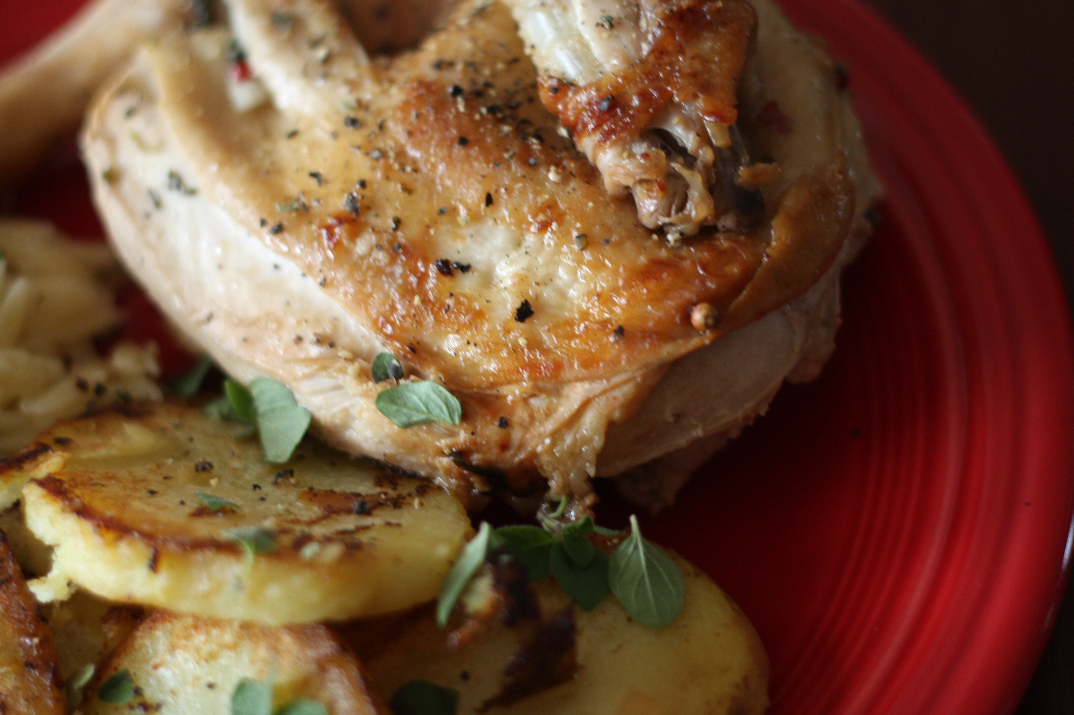
Chicken Riganati a la Michael Psilakis
From his book, How to Cook a Lamb
YOU MUST BUY THIS BOOK! If not for the beautiful photography, the tasty recipes, at least for the stories behind the food. Being Greek myself this book struck such a strong chord with me.
**This recipe is certainly not for the faint of heart or those pressed for time. It requires the removal of most of the bones which is both tedious and time consuming. If that wasnt enough prep work for you, there's a brining step and a marinating step. When pressed for time, dont skimp on the brining step but you can shorten the marinating step if necessary. You will be rewarded with the most flavorful chicken you've ever tasted, I promise!
1 3 1/2 lb chicken (Source: FFM via Pleasant Valley Poultry, ours were between 4-5 lbs)
1 lb yukon gold or fingerling potatoes scrubbed
kosher salt and pepper
olive oil
greek oregano (Source: Fire escape garden, dried is fine if you dont have fresh)
1/2 lemon sliced
2 TBL fresh lemon juice
2 tbl water
butter
Brine (enough for 1 lb meat, make enough for how much meat you have :
1 quart cold water
1/4 C kosher salt
1/4 C granulated sugar (I decided to use dark brown sugar as Ive used it in other brines and prefer it)
1 C distilled white vinegar (*** I would recommend reducing this just a touch)
Marinade (also enough for 1 lb meat, make enough for what you're cooking):
1 C olive oil
3 cloves garlic, smashed and chopped
2 sprigs rosemary
Greek oregano
2 shallots sliced or onion if that's all you have
Essentially you will be spatchcocking your chicken but you also remove the thigh bone. I thought the directions in the cookbook were like reading Greek (haha) but engineer hubby was able to decipher them. The main difference in directions and spatchcocking is that you will cut the bird in half (you'll see what I mean in our plated dinner). The chicken could also be cooked whole, but keep in mind that the bones will add significant cook time. If you do take this task on, save the bones in the freezer for stock later.
Bring the chicken overnight- 12hrs- in the fridge. Marinate the chicken at least 4 hrs but overnight is okay too.
Take chicken out of marinade and let it come to room temp- this is super important for crispy skin. Parboil potatoes in salted water (about 3-4 min), drain well and slice 1/2" thick.
Preheat oven to 375F. Season chicken with just a little S&P and heat some oil in a skillet on high heat. Place chicken skin side down and do not move for at least 4-5 minutes to develop a nice golden crust. Flip chicken meat side down for about 2-3 min. Spoon out some of the fat and place skillet in oven for about 15 minutes or until thermometer reaches 180F.
In a second pan, heat some oil and saute the heck out of those potatoes developing a nice crust.
At this point, I deviated from the recipe because I was just so darn hungry. After I took the chicken out of the oven I poured the juices over the potatoes and added some lemon juice and served the whole shebang up. For the "right" way to do this, you'll have to get the book :)

