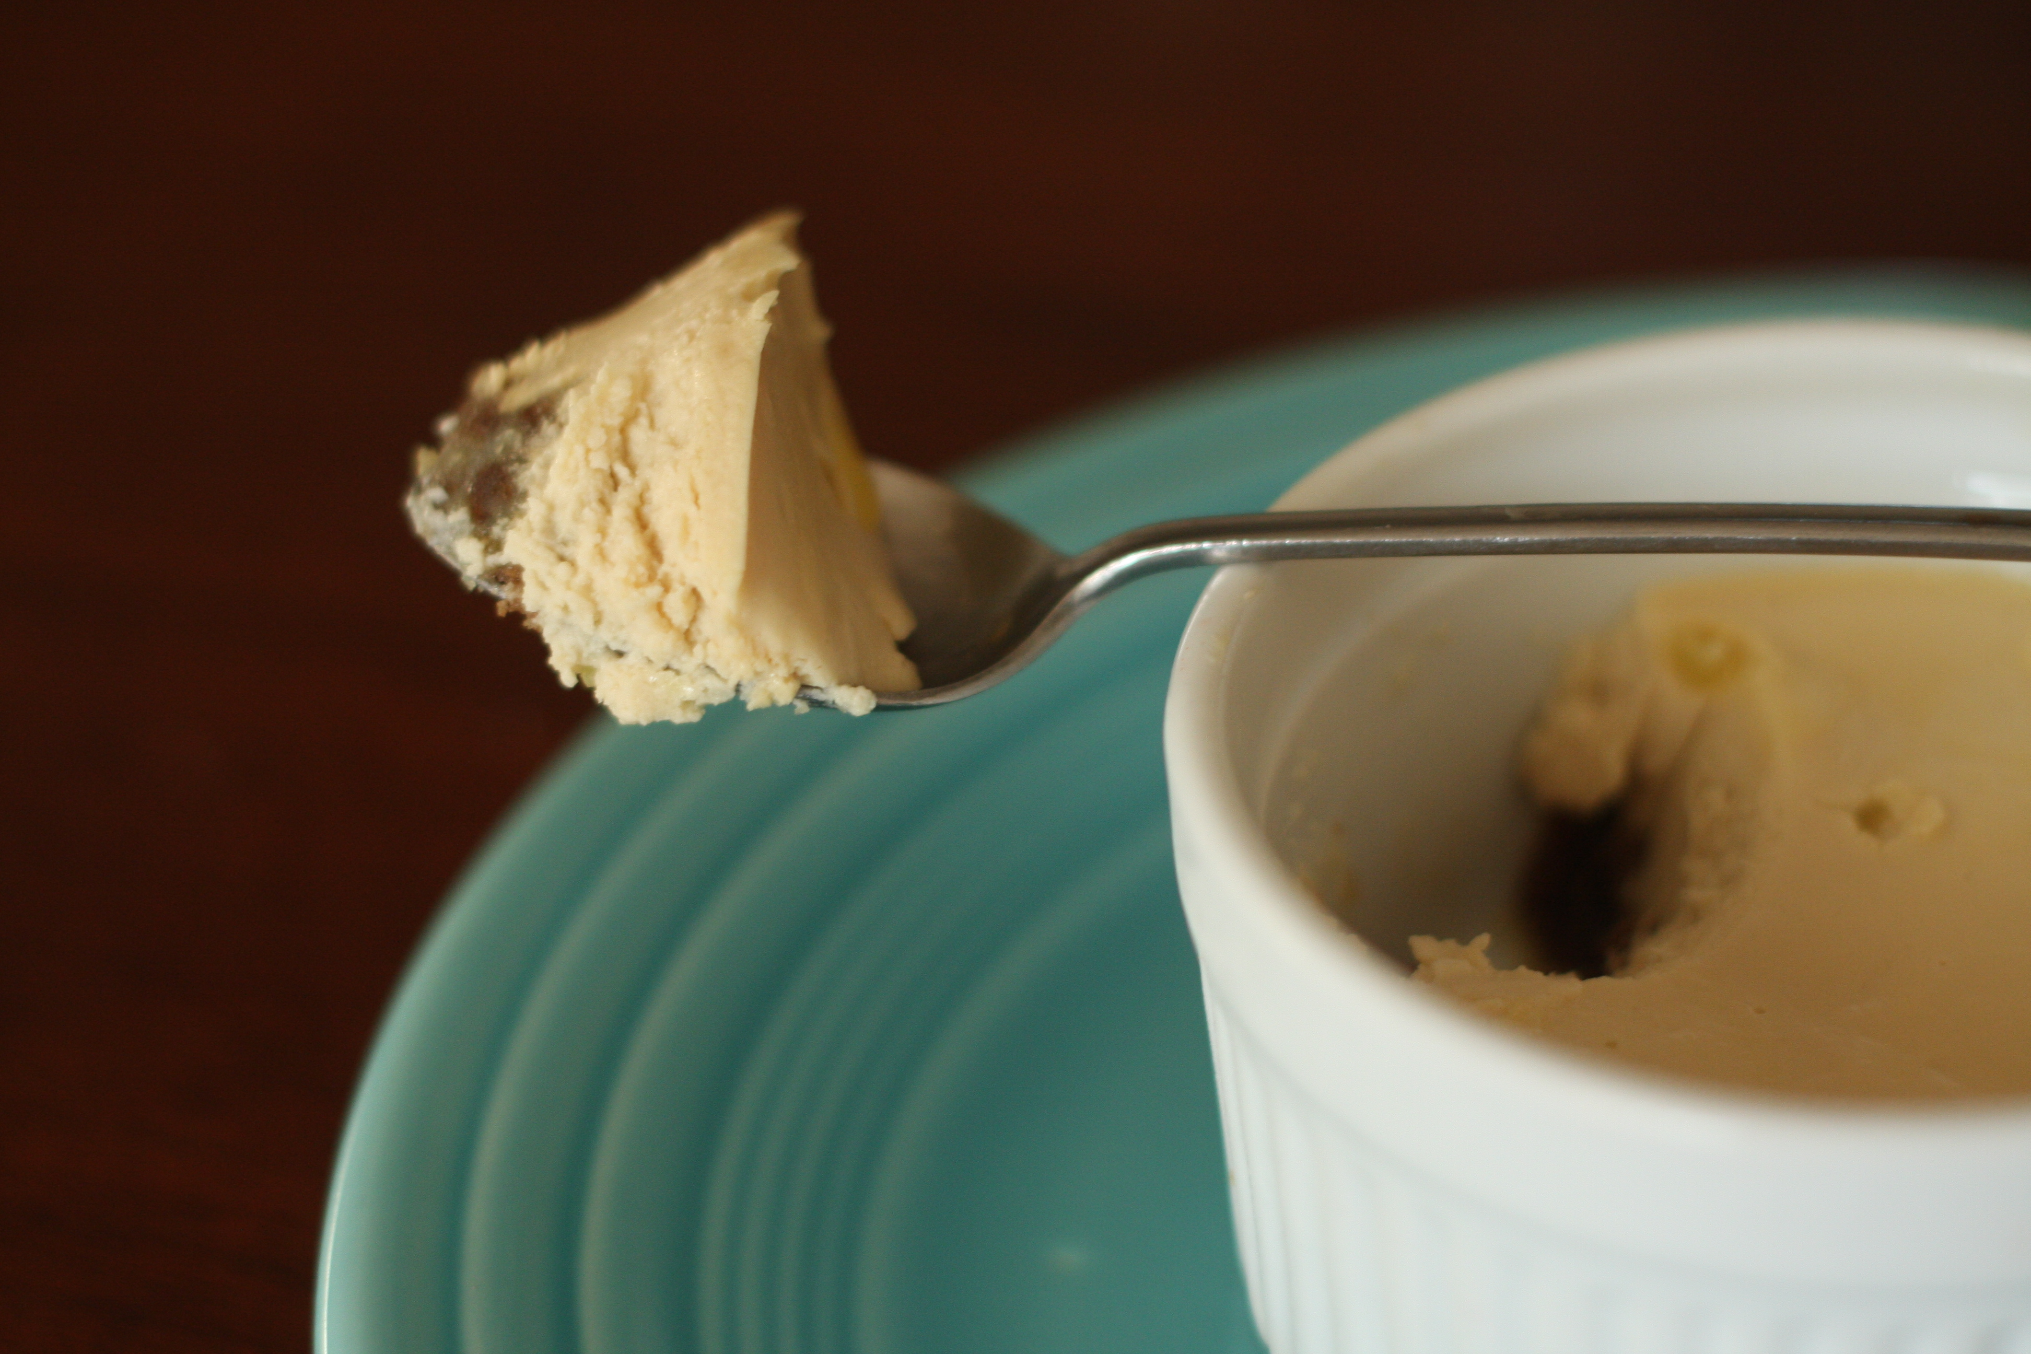

Chevre Cheesecake
**I actually quartered this recipe as I didnt have 8 oz of chevre to work with, and halving it used all of the 4oz I did have which I was totally against. The recipe still turned out great even though I had to use a whole egg instead of 3/4 of an egg :) Top with homemade caramel (I was too lazy), chocolate fudge, fruit compote, or jam. The crust was not in the original recipe but I thought it was worth a try. I made sure to taste the chevre on a bit of cookie before I committed to pairing them together and it was great!
Crust
8-12 crushed ginger snap cookies (Source:
2-3 TBL butter (Source: FFM)
Cheesecake
8 oz Chevre (Courtesy of: Lucky Penny Farm Creamery, no compensation was received for the writing of this post reviewing their chevre. In fact, I dont even think the lady knew I had a blog and was just being generous after I bought some goats milk soap!)
1/2 C soft brown sugar, not packed! (I used dark brown as that was all I had)
1/2 C creme fraiche, I subbed sour cream as that's all I had and it was great!
3 eggs (Source: Holistic Farms, FFM)
Preheat oven to 350F. Melt butter and mix with crushed ginger snaps and press into the bottom of 6 ramekins.
Beat sugar and chevre on medium speed with whisk attachment until completely smooth, scrapping down the sides of the bowl as needed. Add eggs one at a time and continue beating until incorporated. Fret not when the mixture becomes quite runny, the creme fraiche or sour cream will solve that. Beat in creme fraiche or sour cream until batter like consistency. Divide cream mixture between ramekins.
Place ramekins in a roasting pan that can accomodate them all and add boiling water to the pan about halfway up the sides of the ramekins. Bake for 10 minutes and then turn the oven off. Leave cheesecakes in oven while it cools about an hour. When completely cool, tightly cover and refrigerate overnight until serving!

